6.5: a) See Exercise 5.37. The needed force is

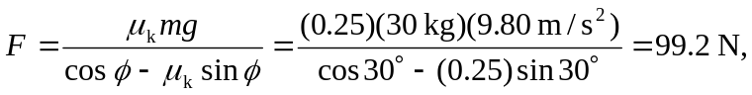

keeping extra figures. b) , again keeping an extra figure. c) The normal force is 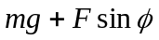, and so the work done by friction is . d) Both the normal force and gravity act perpendicular to the direction of motion, so neither force does work. e) The net work done is zero.

